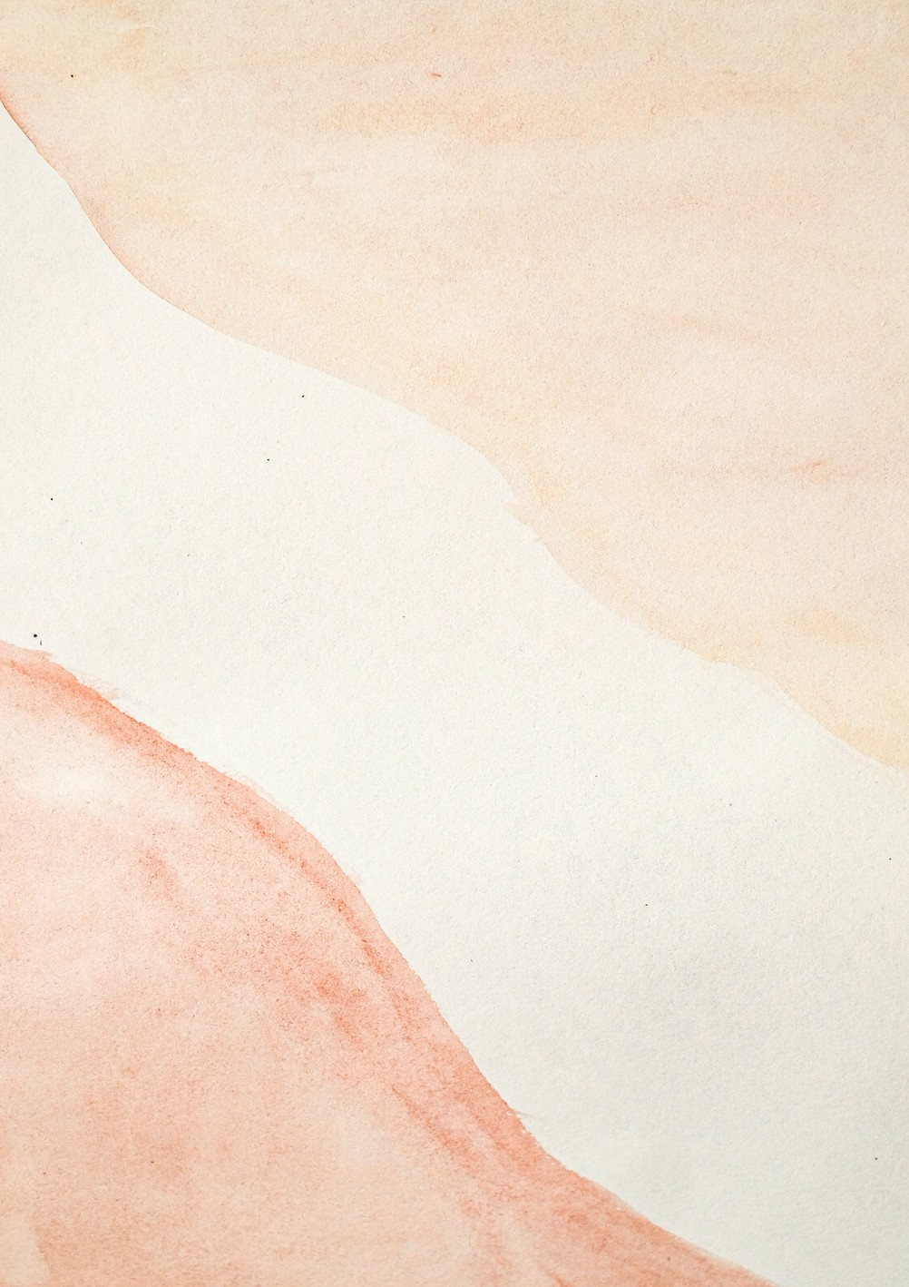Hastings Insurance Services Ltd

|  |  |  |  |  |
| --- | --- | --- | --- | --- |
| **To: Andre Schoombee Attorneys** | **Date:** 29/08/2021  **Invoice#: INUMB_97122Ud**  **PO # : #@_0085830**  **I N V O I C E** | | |  |
| DESCRIPTION | PRICE QTY. | | | AMOUNT |
|  |  |  |  | |
| Website Design | R 895.42 | 375  Total | R 3007.13  R 3007.13 | |
| Total Tax 10% |  | |
| **Grand Total** | R554002 | |
|  | | | | |